**Tableau Assignment: Sales Analysis**

In this assignment, you are required to create a Tableau dashboard using the Sales dataset. Below are the tasks regarding the graphics.

**Task To Do**

* **Revenue per State**

Use Map chart. (Background: Outdoors)

Show total on state.

Change the color “Temperature Diverging”

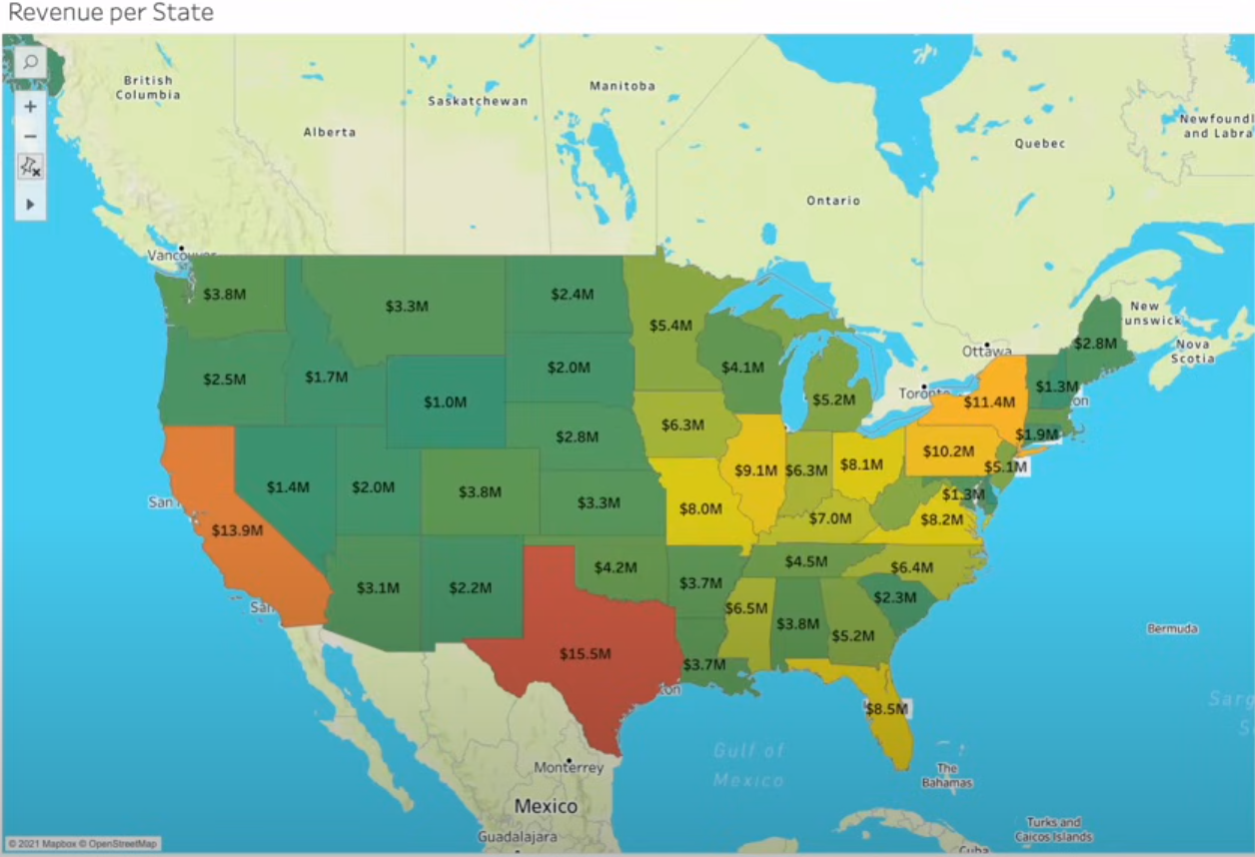

* **Revenue based on Month of the year**

Use Line Chart.

Remove Grid line.

Show Total on Label.

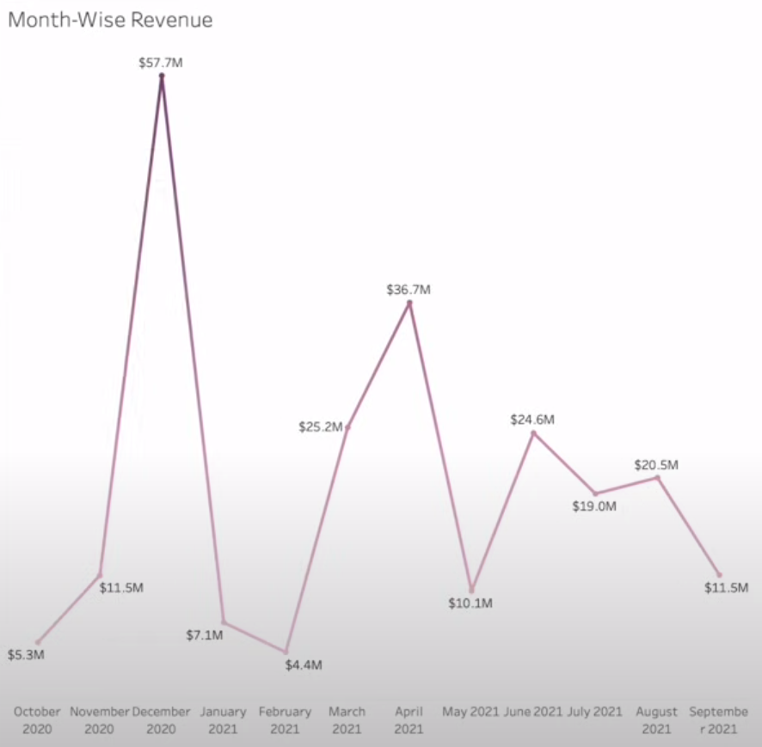

* **Revenue based on Age**

Use Histogram Chart. (Color: Blue – Green Sequential)

Create Bins for Age. (Size of bins:10)

Show Total on Label.

Edit Aliases like picture.

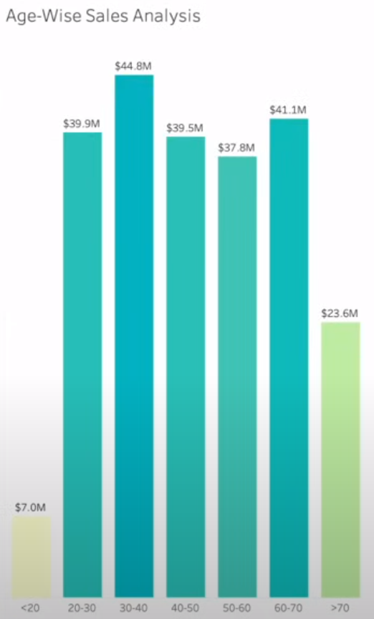

* **Percentage of Revenue per Region**

Use Donut Chart.

Show Label and Totals(percentage)

Labels and chart must be the same color.

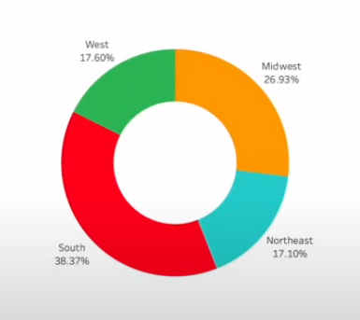

* **Percentage of Catgeory per Gender**

Use Butterfly Chart.

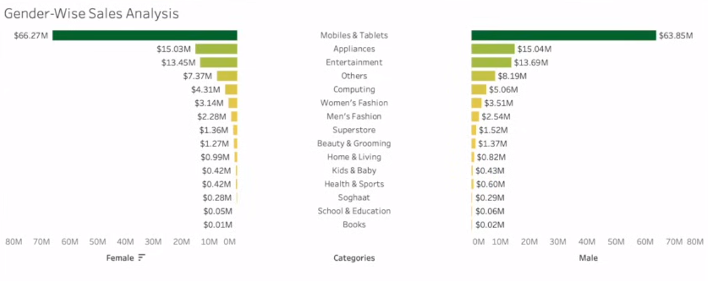

Integrate these graphics into a dashboard. Feel free to add additional charts if you have time.

This assignment should provide students with a comprehensive understanding of data visualization techniques using Tableau while exploring the Sales dataset.